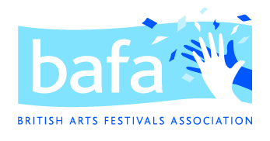

British Arts Festivals Association –
application for Marketing & Communications Manager

Name

Telephone

E-mail

Please tell us about your relevant skills and experience, and in particular any relevant experience you have in using social media to increase stakeholder loyalty and increase business.

[up to 300 words]

We will be commissioning a new website for BAFA and part of your role would be to support the Director and the web designer in ensuring the new website is fit for purpose. What relevant experience can you bring of website development, including any experience of Wordpress sites?

[up to 300 words]

You will need to work as part of a small team to support the communications and advocacy work alongside BAFA’s national research programme, Festivals Mean Business 4. What relevant experience or skills can you demonstrate in arts PR?

[up to 200 words]

If you were offered the role, when would you be able to start, and do you have any significant periods of unavailability that we would need to bear in mind?

This is a home-based role. If you were offered the role, do you have any access needs or support you would need to enable or better support you to undertake the work?

We will be offering interviews by Zoom on Wednesday 3 April. Would you be available for this date if you were shortlisted? Y/N

Please give details of two referees that we could approach for a reference. We would prefer one of these to be from your most recent employer. We would contact you before making an approach to a referee.

First referee:
Name
Job title
Contact e-mail
Relationship to you

Second referee:
Name
Job title
Contact e-mail
Relationship to you

Please return your completed form to bafa@artsfestivals.co.uk by 12pm on Friday 22 March

